**3.4 Table of Values and Linear Equations p. _________**



**Linear Equations** = an equation that results in a ______________ line graph.



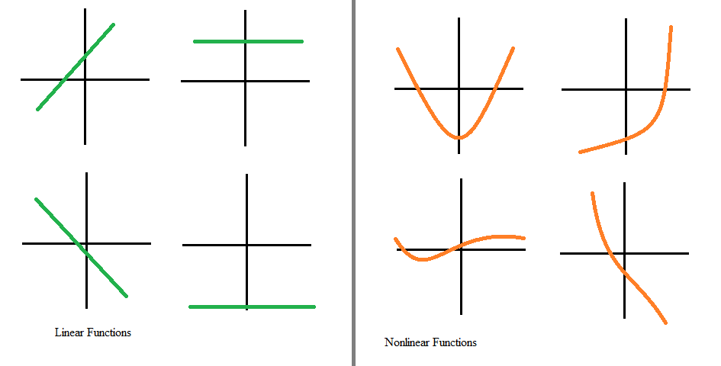

* Can be represented as a ________________ of values, a _________________ , or an ______________________ (*NOTE: Your book sometimes calls this a “****rule****”.)*



**Table of values**

* Find the ________________ across/down the graph.



* Continue the __________________.



Examples:



* If only given an equation, make a table of values by choosing values for _______ and solving for _______.



* HINT: Choose simple integer values: ________________________________



Examples:

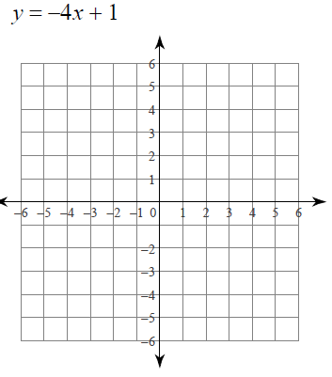



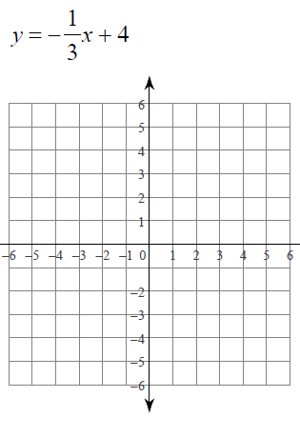



Now, suppose one variable is equal to _______________.



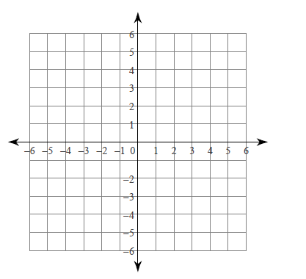

1. x + y = -2 and y = 0



**x = a** will ALWAYS be a ___________________



line and every x-coordinate will be ______.



1. x + y = 3 and x = 0



**y = a** will ALWAYS be a ___________________



line and every y-coordinate will be ______.



**Equation - ___________________**



* Use the table of values to find ________



* Make sure your x-values are in _____________________ order!!



* Substitute in a value for x & y from your table to find _________



* Write the equation in __________________________________ form.



Examples:

|  |  |  |  |  |
| --- | --- | --- | --- | --- |
| x | 0 | 1 | 2 | 3 |
| y | -2 | -6 | -10 | -14 |



Equation (Rule) = _______________________



|  |  |  |  |  |
| --- | --- | --- | --- | --- |
| x | -2 | 0 | 2 | 4 |
| y | 3 | 4 | 5 | 6 |



Equation (Rule) = _______________________



***Homework: p. ________ #1-3 for novice, #1-4 for apprentice/expert***

