*Math 9 Name:*

**3.5 Graphs and Linear Relationships (Part A) p. _________**



1) A landscape designer uses wooden boards as edging for the plots in a herb garden. The boards are all the same size.

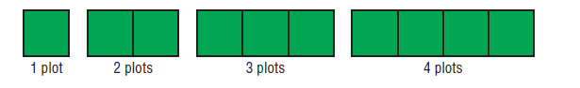



The number of boards *b* is related to the number of plots *p* .



Let’s look at a table of values:



|  |  |
| --- | --- |
| # of plots *p* | # of boards *b* |
| 1 |  |
| 2 |  |
| 3 |  |
| 4 |  |



Developing an equation:



a) If I want to make 39 plots, how many boards do I need?



b) If I have 73 boards, how many plots can I make?



2) Here is a table of data for the height *h* of an airplane (in meters) at time *t*, (in minutes) determine an equation for height in terms of *t* .

How high are you at the 11 minute mark?

|  |  |
| --- | --- |
| Time *t* | Height *h* |
| 0 | 10 000 |
| 1 | 9 700 |
| 2 | 9 400 |
| 3 | 9 100 |
| 4 | 8 800 |



3) Write an equation relating the variables.



a) Find y when x = 40. b) Find x when y = 100.

|  |  |
| --- | --- |
| *x* | y |
| 2 | -4 |
| 4 | -8 |
| 6 | -14 |
| 8 | -16 |

|  |  |
| --- | --- |
| *x* | y |
| 1 | 6 |
| 2 | 4 |
| 3 | 2 |
| 4 | 0 |



***Worksheet 3.5***

