6.2 Similar Triangles (p. 151)

Triangles are similar if either:

1. The ratios of their corresponding sides are equal.

For example:

OR

2. Corresponding angles are equal

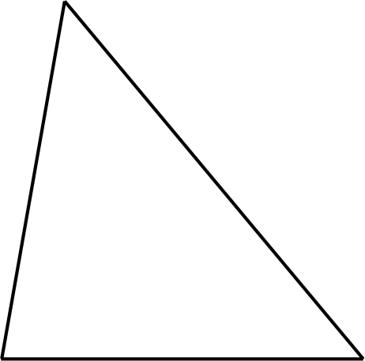

Example 1: If ΔABC is similar to ΔDEF, find x

Example 2: Find x.

Example 3: Is ΔABC similar to ΔCDE?

Example 4: Mrs. Sharp stands 1.5m tall and casts a 1.2m shadow. At the same time of day, the school's shadow is 8m long. What is the height of the school?
(Note: Diagram is NOT to scale. Do not assume it is unless told so!)

Example 5: A surveyor wants to determine the width of a river to build a bridge. Using her surveying equipment, these measurements were taken:

Homework:

