6.3 Similar Polygons (p. 156)
Similar polygons – polygons (__________________________________) that are enlargements or reductions of each other.
- Have the same __________________ but different __________________
- All corresponding __________________ are the _________________
- All ratios of corresponding ______________ are in _____________________________ (meaning they have the same ___________________________)
Example 1:
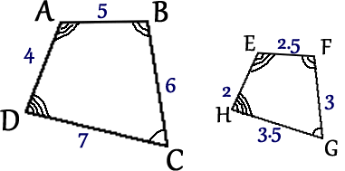
These quadrilaterals (4-sided polygons) are similar because:

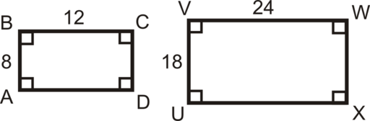
Example 2: Find the length of AB. Two methods:
- By inspection

Example 3: Find m. 2. By cross-multiplying
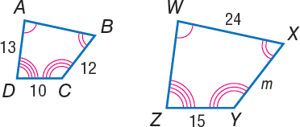

Example 4: Find x.
x mm
3 mm
5.4 mm
8.1 mm

