**Sec. 6.5 Enlargements and Reductions (p. 149)**

To calculate scale factor (SF):



Scale factor = ______________________



You can arrange this formula in a triangle:

SF =



Changed figure =



Original figure =



NOTE: Figure size units MUST be the same!



Enlargement:



* The original drawing/diagram has expanded its size but does NOT change its shape.



* Will have a scale factor ______________________ than one.



Reduction:



* The original drawing/diagram has contracted in size but it does NOT change its shape.



* Will have a scale factor ______________________ than one.



Example 1:



[](http://www.google.ca/url?sa=i&rct=j&q=&esrc=s&source=images&cd=&cad=rja&uact=8&ved=0ahUKEwiUidHdj-nTAhVUVWMKHZETCT4QjRwIBw&url=http://clipartix.com/flowers-clipart-image-4947/&psig=AFQjCNEQp50dxjPr-T4GCYoFT9fBbsSqlQ&ust=1494636149594728)Example 2:

[](http://www.google.ca/url?sa=i&rct=j&q=&esrc=s&source=images&cd=&cad=rja&uact=8&ved=0ahUKEwiUidHdj-nTAhVUVWMKHZETCT4QjRwIBw&url=http://clipartix.com/flowers-clipart-image-4947/&psig=AFQjCNEQp50dxjPr-T4GCYoFT9fBbsSqlQ&ust=1494636149594728)



Example 3: Enlarge by a scale factor of 2.



[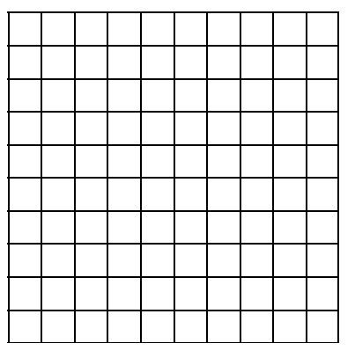](http://www.google.ca/url?sa=i&rct=j&q=&esrc=s&source=images&cd=&cad=rja&uact=8&ved=0ahUKEwjh1Pu0kOnTAhVLyGMKHZN3DisQjRwIBw&url=http://www.jamesrahn.com/pages/other/Graph%20Paper.html&psig=AFQjCNF00PQQAjf3571-XJEqsZ341bE2Sw&ust=1494636342008702)



[](http://www.google.ca/url?sa=i&rct=j&q=&esrc=s&source=images&cd=&cad=rja&uact=8&ved=0ahUKEwjh1Pu0kOnTAhVLyGMKHZN3DisQjRwIBw&url=http://www.jamesrahn.com/pages/other/Graph%20Paper.html&psig=AFQjCNF00PQQAjf3571-XJEqsZ341bE2Sw&ust=1494636342008702)Example 4: Reduce by a scale factor of 1.5.

