

**Sec. 6.6 Scale Diagrams (p. 152)**



* Used to draw an object when it is ___________________________to draw the object its actual size



* + For example:



distance between the moon and Earth - too __________________



diagram of a bacterial cell - too __________________



* has a _________________________



* + ratio of the length of the image to the length of the actual object



For example:



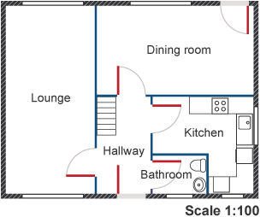



* + measured in the same ________________________



* + image can be a ________________________, ________________________, or ____________________



* + always reduced so that the smaller unit is equal to _____________________



* + Can be written in fractional form (scale factor):



**Example 1**: If 4 mm represents 6 cm, what is the scale?



**Example 2**: If 2 cm represents 300 km, what is the scale?



**Example 3**: If 5 cm represents 2 mm, what is the scale?



**Example 4**: If the scale is 1:20 and the drawing length is 4 cm, what is the actual length?



**Example 5**: If the scale is 4:1 and the actual length is 25 mm, what is the model's size?



**Example 6**: If the following pyramid is reduced by a scale of 1:4, what are the dimensions of the scale diagram?



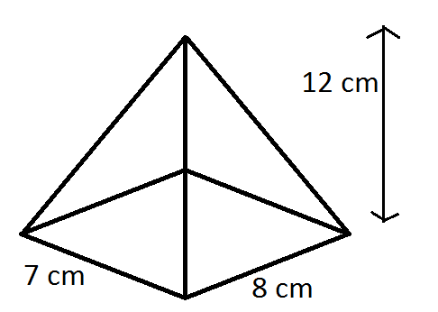



**Example 7**: Height of a building on a drawing is 6cm. If the scale is 1:300, how tall is the actual building?

