Chapter 15: Classification

Read Ch.15 and answer the following questions.

1. What is taxonomy?

2. Explain how the following are used for classification (remember what you’ve learned in the Evolution Unit).

a) morphology (ex. Homologous & vestigial structures) –

b) embryology –

c) biochemistry/genetic evidence –

3. What is a species?

4. Why are mules not classified as a species?

5. What is the binomial nomenclature systems?

6. Felis catus and Felis leo belong to the same _____________ but to different ____________________.

7. As you move from Domain to Species, the organisms have more & more characteristics that are ___________________.
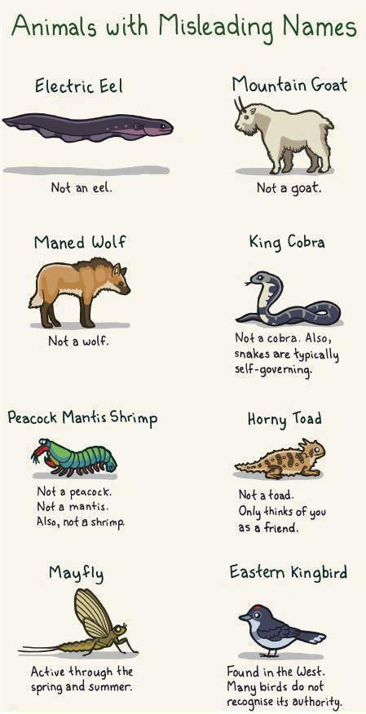
8. List the classification groups from largest to smallest.

9. List the six kingdoms in the 6-Kingdom Classification System.

10. Describe how you write the scientific name for an organism.

11. From the textbook, do the following questions:
p. 320 #3 p. 325 #1
p. 323 #2 p. 329 #2 & 3

