Comparing Photosynthesis and Cellular Respiration

Photosynthesis:

____________________________________________
(equation)
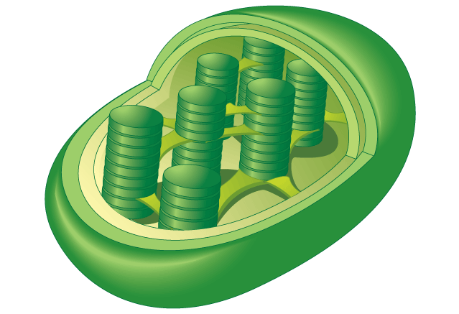

Cellular Respiration
________________________________________________
(equation)

