**Notes: Measurement**

**Unit Conversion: Three Methods**



Method 1: Table



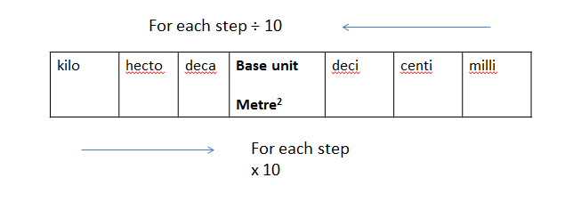



**Example:** 180.5 dm to km



Method 2: Staircase



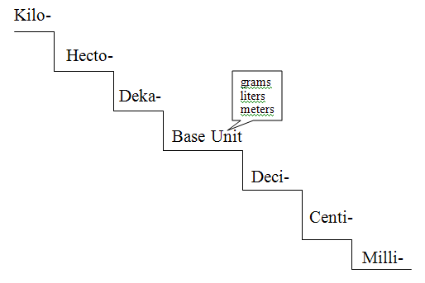



**Example:** 1.5 dam to cm



Method 3: Data Analysis



**Example:** 6.2 m to cm



**Example:** 7500 um to km



Try:

1. 8 cm to mm



1. 520 mm to m



1. 0.4 km to cm



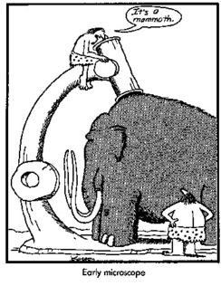



1. 3.5 um to mm



**Estimation Size of Micro-organisms**



* **Field diameter is also known as field of view or** FOV



* If the specimen looks like it is 1/4 as long as the FOV is wide using the medium power you would multiply the FOV by 1/4 (or divide by 4) to get the approximate size of the structure.



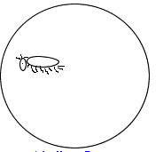



**Examples:**

1. A bacterial cell stretches $\frac{1}{3}$ way across a 1500 um field of view. Approximately how big is the bacterial cell?



1. Eight cells fit across the 400 um. Approximately how big is the cell?



1. A bug stretches $\frac{4}{5}$ way across 2000 um. Approximately how big is the bug?



**Magnification**

[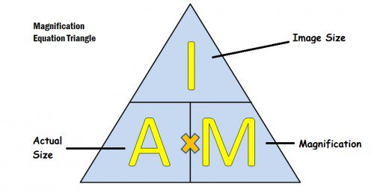](https://www.google.ca/url?sa=i&rct=j&q=&esrc=s&source=images&cd=&cad=rja&uact=8&ved=0ahUKEwjAxLTVu8nXAhVLx2MKHSSTCOoQjRwIBw&url=https://owlcation.com/stem/light-and-electron-microscopy&psig=AOvVaw16hefzcLvkwMCu5JakFAxn&ust=1511140620629638)

NOTE: **Always** make sure the units are the same before you do your calculation.



**Examples:**

1. Actual size == 200 um



Drawing size = 5 cm



Magnification of drawing = ____________



1. Actual size = _________ um



Drawing size = 30 mm



Magnification of drawing = 5000X



1. Actual size = 1000 um

Drawing size = ___________ cm



Magnification = 40X

