Microscope Worksheet (pp. 34-37 & Appendix C p. 4-5)

- How do you carry a microscope? _________________________________________________________________
_______________________________________________________________________________________________________

- What is the total power of the following objective lenses?
  - Medium: ________________
  - Low: ___________________
  - High: ___________________

- Which knob should you NOT use on the high power? WHY? __________________________________
_______________________________________________________________________________________________________

- What is the magnification of the eyepiece? ____________________________

- Why is there an x behind each power, like 4X or 100X? _______________________________________
_______________________________________________________________________________________________________

- What is the lens in the eyepiece called? _______________________________

- How do you prevent the slide from falling off the stage? _______________________________________

- Which adjustment knob is used for large adjustments in focusing? __________________________

- Which adjustment knob is used to sharpen the image? ________________________

- What is the function of the diaphragm? __________________________________________________________
_______________________________________________________________________________________________________

- How do you change the objective lenses? ________________________________________________________
_______________________________________________________________________________________________________

- What power must be in place to first find an image in a microscope?_________________________

- Describe what needs to be done to properly put your microscope away? _____________________________________________________________________________________________________________________________________________________________________________________________________________________________________________________________________________________________________________________
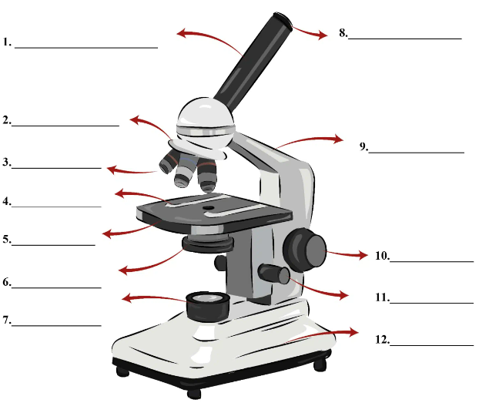
- Fill in the blanks on this diagram and describe each function in the table below.

# | Function
1
2
3
4
5
6
7
8
9
10
11
12

