Natural Selection in the Face of Climate Change
SPECIES 1 – SNOWSHOE HARE
Independent variable: Month during which the snowshoe hare changes to white
Dependent variable: Number of individuals
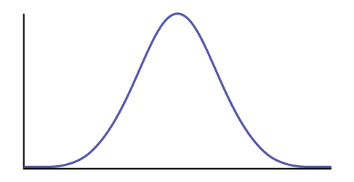

Nov

SPECIES 2 – BALTIMORE ORIOLES
Independent variable: Latitude at which Baltimore Orioles breed
Dependent variable: Number of individuals

40°

SPECIES 3 – MAGELLANIC PENGUIN
Independent variable: Day on which plumage provides protection to juvenile penguins
Dependent variable: Number of individuals

40
SPECIES 4 – PACIFIC NORTHWEST SHELLFISH
Independent variable: Shell weight (g)
Dependent variable: Number of individuals

1200

SPECIES 5 – CASCADE FROG
Independent variable: Number of days spent in larval stage
Dependent variable: Number of individuals

90

SPECIES 6 – RED KNOT
Independent variable: Month red knots arrive in Delaware Bay
Dependent variable: Number of individuals

May

