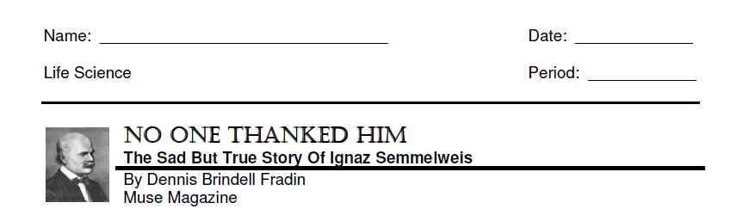

Answer the following questions.

1. What observation did Ignaz Semmelweis make in the obstetrical clinic that he was hired to run in Vienna, Austria in 1846?

2. Why did expectant mothers not want to deliver their babies in Vienna General Hospital’s
First Obstetrical Clinic?

3. What did explanation was given to explain the deaths?

4. What tragedy revealed the answer to why mothers who recently gave birth were dying in the First Obstetrical Clinic?

5. Why did Dr. Semmelweis not believe the explanation given? What was Dr. Semmelweis’ hypothesis?

6. What did Dr. Semmelweis ordered to be done to combat “childbed fever” in his hospital? Did it work? Provide data that supports your answer.

7. Did other doctors agree with Dr. Semmelweis’ discovery? What happened to Ward No 1?

8. What happened to Dr. Semmelweis?

9. How did Dr. Semmelweis’ unappreciated work influence future medical practices? How has it affected your life? State your opinion and your reasoning in a minimum of four complete sentences in a cohesive paragraph.

________________________________________________________________________________________________________________________________________________________________________________________________________________________________________________________________________________________________________________________________________________________________________________________________________________________________________________________________________________________________________________________________________________________________________

