**Lesson 5: Banking**

1. **Types of Accounts**

Financial institutions offer several different types of bank accounts.



_________________ accounts provide cheques but little to no interest. These accounts are designed to be used daily for most day to day banking. These accounts come with cheques.



_________________ accounts provide interest and are designed to provide a place to keep money for long-term money-management.



_________________ accounts are designed for students either in high school or college/university. Age and enrollment in a school is a factor. A reduced (or no) account fee is assigned to these accounts.



You can find these different types of accounts on financial institutions websites or at a local branch. Different accounts and their services and fees are explained before you sign up. We will use the Northwest Bank of Canada Service packages sheet for some example questions.

Example:

Tiffany completes on average 27 self-serve transactions and uses a teller once. She sends 3 email money transfers per month and maintains a balance of $1000. She is enrolled at Okanagan College. Determine the amount she would pay for each of the accounts.

|  |  |  |  |  |
| --- | --- | --- | --- | --- |
|  | **Fee** | **Transactions** | **EMT** | **Total** |
| **Self-Service** |  |  |  |  |
| **Full-Service** |  |  |  |  |
| **Student** |  |  |  |  |
| **Savings** |  |  |  |  |

*Complete Part A on Worksheet*

1. **Bank Records**

It is important to know the balance in your bank account. Every month many transactions can be occurring in and out of your chequing account. Every cheque written, every debit card purchase, and every deposit you make. If you are not careful and don’t know the balance of your account, you can get into financial trouble if you overdraw your account.

Use the information below to fill in a blank account register. Remember, when you make a withdrawal, pay a bill or take money out of your account, you subtract. When you make a deposit, or put money into your account, you add.

1. On May 4, your balance is $625.68.
2. On May 8, you use your debit card to pay for groceries at Safeway in the amount of $110.75
3. On May 12, you complete an email money transfer to your sibling for $80.00.
4. On May 15, your paycheque of $235.00 is automatically deposited.
5. On May 17, you write cheque #45 for $145.82 to Northwest Bank of Canada for your car payment.
6. On May 18, an automatic withdrawal of $105.45 to ICBC is completed.
7. On May 28, you write cheque #46 to your landlord, Mr. Jones for $350.00.
8. On May 29, you deposit $120.00 in your chequing account using an ATM.

|  |  |  |  |  |  |  |  |  |
| --- | --- | --- | --- | --- | --- | --- | --- | --- |
| Cheque No. | Date | Description | Withdrawal | | Deposit | | Balance | |
|  |  |  |  |  |  |  |  |  |
|  |  |  |  |  |  |  |  |  |
|  |  |  |  |  |  |  |  |  |
|  |  |  |  |  |  |  |  |  |
|  |  |  |  |  |  |  |  |  |
|  |  |  |  |  |  |  |  |  |
|  |  |  |  |  |  |  |  |  |
|  |  |  |  |  |  |  |  |  |
|  |  |  |  |  |  |  |  |  |
|  |  |  |  |  |  |  |  |  |
|  |  |  |  |  |  |  |  |  |
|  |  |  |  |  |  |  |  |  |
|  |  |  |  |  |  |  |  |  |
|  |  |  |  |  |  |  |  |  |
|  |  |  |  |  |  |  |  |  |
|  |  |  |  |  |  |  |  |  |
|  |  |  |  |  |  |  |  |  |
|  |  |  |  |  |  |  |  |  |

1. **Writing Cheques**

Cheques are an important non-cash method of paying for items or for securing deposits. A cheque orders a bank to pay a specific amount of money from a person’s account where their money is held.

What are some reasons a person would use a cheque rather than using cash?



The use of cheques is declining in popularity in favor of electronic methods of payments (i.e. email money transfers). However, they are still a useful method of payment and billions of cheques are cashed each year.



It is important to know that to write a cheque, there must be sufficient funds in the chequing account to cover the amount. Writing a cheque when you know there is not enough money in the account to cover it is a violation of the law. This is called writing a “bad cheque”. Individuals who write “bad cheque” may be fined or otherwise punished.

Some other terms you may come across:



Non-sufficient funds (NSF) - ____________________________________________



__________________________________________________________________



Post-dated - ________________________________________________________



__________________________________________________________________



Stop payment - _____________________________________________________



__________________________________________________________________



Counter-signed cheque - ______________________________________________



__________________________________________________________________



Mobile cheque deposit - _______________________________________________



__________________________________________________________________

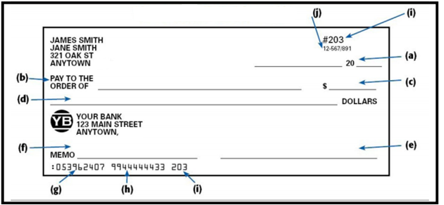

**YOUR BANK**

**123 MAIN ST**

**ANYTOWN, CANADA**

**CANADA**

**YOUR NAME**

**1234 OAK ST**

**ANYTOWN, CANADA**

**CANADA**

Describe each area of the cheque in the following table.

|  |  |
| --- | --- |
| **Cheque Area** | **Description** |
| (a) | Date: Includes the month, day and year that the person wrote the cheque. |
| (b) |  |
| (c) |  |
| (d) |  |
| (e) |  |
| (f) |  |
| (g) |  |
| (h) |  |
| (i) |  |

There are 6 parts to writing a cheque.

1. Date
2. Name or organization being paid
3. Amount in numerals
4. Amount in words (see below)
5. Signature line
6. What the transaction is for

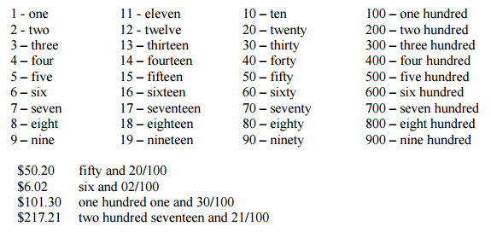

Examples: complete the following cheques:



1. Cheque #101 to George Smith for $75.23.



1. Cheque #104 to Toyota for $920.00.



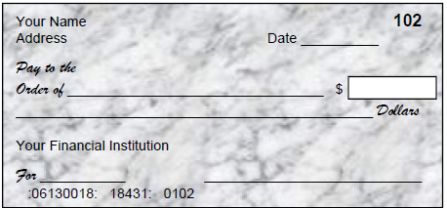



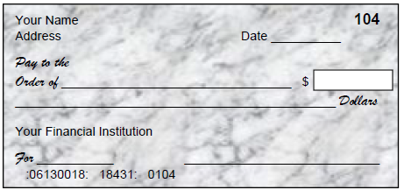



*Compete Part C on Worksheet*