BIOLOGY 11 UNIT OUTLINE

UNIT 7: KINGDOM ANIMALIA – LOWER INVERTEBRATES

A. Chapter 26: Sponges, Cnidarians, & Unsegmented Worms pp.554-583
E. Chapter 30: Comparing Invertebrates pp. 652-673

Learning Outcomes:

It is expected that students will:

- analyse how the increasing complexity of animal phyla represents an evolutionary continuum
- analyse the increasing complexity of the Phylum Porifera & the Phylum Cnidaria
- analyse the increasing complexity of the Phylum Platyhelminthes, the Phylum Nematoda, & the Phylum Annelida
- relate the complexity of the form & function of vertebrates to the evolutionary continuum of animals
- First Peoples understandings of animal body plans

Knowledge:

• trends of increasing complexity in animal lifeforms
• characteristics of Phylum Porifera, Cnidaria, Platyhelminthes, and Nematoda
• how animals in each phylum carry out their life functions
• ecological significance of various animal phyla

Vocabulary:

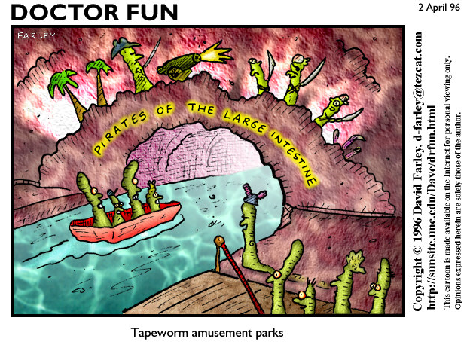
Acoelomate, amoebocyte, anterior, asexual reproduction, assymetrical, bilateral symmetry, budding, cell, cephalization, closed circulatory system, coelom, colonial, collar cell, dorsal, excretion, filter feeding, free-living, ganglia, gastrovascular cavity, gemmule, hermaphrodite, internal transport, invertebrate, larva, levels of organization, life functions, medusa, motility/motile, multicellular, nematocyst, open circulatory system, organ, organ system, osculum, ostia, parasite/parasitic, pharynx, polyp, posterior, pseudocoelomate, radial symmetry, reproduction, respiration, response, segmentation, sessile, sexual reproduction, spicule, symmetry, tissue, ventral, vertebrate

