Rational Numbers Project

“Pixel Art”

Name ____________________________ Date: ____________________

Curricular competency being assessed: Reasoning & Analyzing

Content:

Operations with rational numbers

BEGINNING | DEVELOPING | PROFICIENT | EXTENDING
I can…

- Apply (use) my rational number skills to model number classification accurately and as specifically as possible.

- Use math skills to accurately create an image using rational numbers.

- Using mental math and estimation, I am able to correctly order rational numbers from least to greatest.

- Reflect on the importance of rational number skills to the real world.

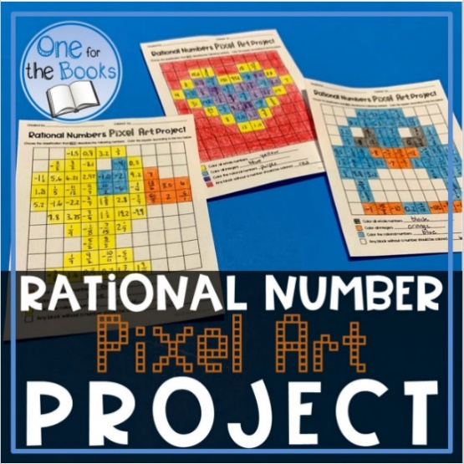

Task:
You will be creating a colour-by-numbers picture using rational numbers. Your image will be created on a grid paper. All squares do not have to include a number. Empty squares must all be the same colour but can be used as part of your image.
You will submit your rough draft (with the intended image colored) along with your final copy and an answer key. Your final copy should be clearly communicated - extremely neat, easy to read/understand, and free of errors.
Remember to classify your numbers correctly. For example, one of the required numbers is an integer written as a fraction. For example, $\frac{10}{2}$ fulfills this requirement; however, make sure you place it correctly. This number best fits in the category “natural number”. Be sure to choose a number that meets the criteria but be careful when placing it on your grid to ensure your image portrays your intended design.

Instructions:
Step 1: Create a rough draft of your design on graph paper. Your design should be creative, original, and must consist of at least 5 colours.
Step 2: After creating your rough draft, you will come up with numbers that meet the criteria (i.e. natural number, whole number, etc.) for each colour.
Step 3: Organize and write your numbers on your final copy of the project so that when the colour key is followed correctly, the grid will reveal the image from your rough draft.
Step 4: Complete a separate answer key.

Requirements:
- The project must include at least thirty numbers; however, you may include more if you prefer.
- You must include your rough draft, a separate answer key, and your reflections.
- Put your name on your project.

Reflections: On a separate piece of paper, answer the following questions. Be thoughtful, clear, and specific.
- Using your mental math and estimation skills, put the five rational numbers you choose in order from least to greatest. Ensure that you show how you used your skills so that it is apparent you did NOT use a calculator.
- Reflect on the importance of rational number skills in the real world. Specifically describe how rational numbers are used and why it would be important to understand them.
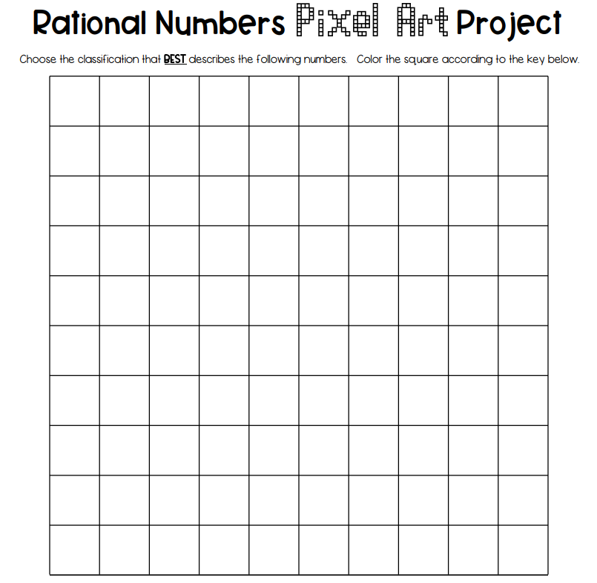
urn in your rubric with your final project.
DRAFT

Colour all natural numbers __________________________________
Colour all whole numbers __________________________________
Colour all integers __________________________________
Colour all rational numbers __________________________________
Colour all irrational numbers __________________________________
urn in your rubric with your final project.
FINAL

Colour all natural numbers __________________________________
Colour all whole numbers __________________________________
Colour all integers __________________________________
Colour all rational numbers __________________________________
Colour all irrational numbers __________________________________
urn in your rubric with your final project.
KEY

Colour all natural numbers __________________________________
Colour all whole numbers __________________________________
Colour all integers __________________________________
Colour all rational numbers __________________________________
Colour all irrational numbers __________________________________

