**3.3 Modeling Situations Represented by 1st Degree Expressions p. _________**



Mathematical relations can be represented by using:

1. ______________________



1. ______________________



1. ______________________



Example 1: Here is a pattern with toothpicks. How many toothpicks are needed to draw 6 triangles?



[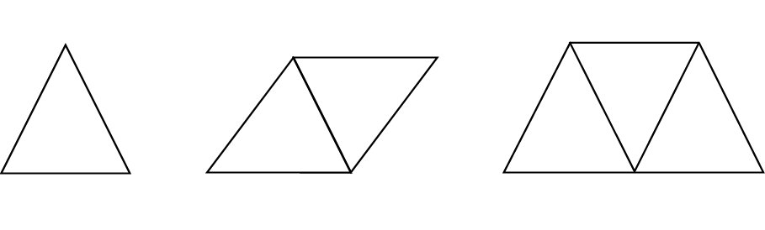](https://archive.cnx.org/contents/86a34849-8c62-45c8-ab42-543ff31ebd4d@1/investigate-and-approximate-the-area-of-polygons)



1. Using pictures to solve:



1. Using a table of values:



* + Fill in the table with what you know:



* + Look for the pattern going DOWN the table:



* + Continue the pattern until you find your answer.



1. Using an equation: ______________________________



Two methods to come up with your equation:

Method 1: Use your table of values



* The pattern (rise/run) is equal to ________



* Substitute in one of your given values for ___________ and ____________



* Decide what must be added/subtracted (if anything) to solve for _________



* Rewrite your equation with x & y: _______________________



* Solve the question asked.



Method 2: Start with numbers.



Example: Johnny has a window cleaning service. He charges a fixed cost of $15 plus $1.50 per window.



1. How much will it cost for “n” windows?



* Start with finding the cost of 1, 2, or 3 windows:



* Change the numbers into a variable:



b) How much will Johnny charge for cleaning 20 windows?



Review: Substituting in values.

Example 1: The area of a trapezoid is found using the formula: $A=a\left(\frac{b+c}{2}\right)$



Find the area if a = 2.5 cm, b = 5 cm, and c = 7 cm.



Example 2: Using the equation, 2x + 14 = 6y, find y if x = 5.



***Homework: p. ________ #1-5 for novice, #1-8 for apprentice, or #1-9 for expert***

