Sec. 3.4: Horizontal, Vertical, and Oblique Lines
1. Does each equation describe a vertical, a horizontal, or an oblique line?
Describe each vertical or horizontal line.
a) y = 4 b) 2x + 5 = 7

c) 2x – y = 6 d) 3y + 9 = 0

2. Which equation below describes each graph?
a) b)
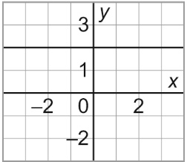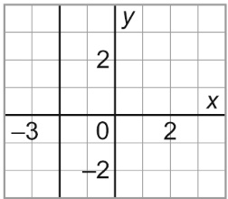
i) x = 2 ii) x = –2
iii) y = 2 iv) y = –2
3. The sum of two numbers is 8. Let x and y represent the two numbers.
a) Create a table for 5 different values of x.

b) Graph the data. Should you join the points?

c) Write an equation that relates x and y.
4. On the back, graph each line. Show your work.
a) x = 4 b) 2y = 6
c) y – 2 = 3 d) 2x + 3 = 8

5. a) Graph these equations on the same grid.
x + y = 6 y = 1 x – y = –6
b) Which shape is formed by these lines?

