Taxonomy (Classification) Test Outline
Reading: Ch.15 pp.318-333

Concepts to study:
_____ 1. Explain why we classify organisms.
_____ 2. What language is used in classification?
_____ 3. Explain what is used to help classify organisms.
_____ 4. Who developed binomial nomenclature?
_____ 5. Describe how you properly use binomial nomenclature.
_____ 6. Recognize proper binomial nomenclature
_____ 7. Name the 8 taxa in order from smallest to largest or most general to most specific.
_____ 8. Know a human being’s complete taxonomic classification.
_____ 9. Be able to distinguish which organisms are more closely related by their classification.
_____ 10. Distinguish between prokaryotic & eukaryotic cells.
_____ 11. Distinguish between the 3 domains of life & give examples in each.
_____ 12. Distinguish between the 6 kingdoms of life & give examples within each.
_____ 13. Give similarities & differences between the 6 kingdoms.
_____ 14. Given descriptors, be able to distinguish which kingdom the unknown organism belongs.
_____ 15. Explain what a dichotomous key, a phylogenetic tree, and a cladogram is.
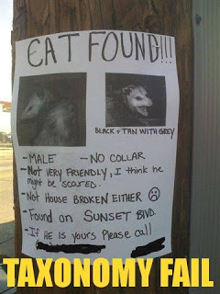
_____ 16. Be able to use a dichotomous key, a phylogenetic tree, and a cladogram.
_____ 17. Be able to design a small dichotomous key and a cladogram.

You should also:
- read the assigned reading
- go through your notes
- know your vocabulary (on the course outline & new words in your notes)
- review your textbook questions & worksheets
- ask questions

