Foundations & Pre-Calculus Math 10
Course Outline
Mrs. J. Sharp

Course Overview:

Unit 1: Financial Literacy Unit 2: Trigonometry
Unit 3: Factors & Products Unit 4: Roots & Powers
Unit 5: Relations & Functions Unit 6: Linear Functions
Unit 7: Systems of Linear Equations & Arithmetic Sequences

Class supplies:
- 3-ring binder with dividers and lined paper
- pencils and eraser
- ruler & protractor
- Scientific calculator (you may not use your cell phone!)
- graph paper

Binder: Divide your notebook into four sections:
- A section containing warm-up questions which may be given at the start of class.
- A section containing class notes and examples.
- A section containing day-to-day homework (textbook work). This will be your practice prior to formal assessment. It is NOT optional & will be checked.
- A section containing your unit assignments. These will be marked.

Homework:
Homework will be handed in for completion. Each homework assignment will be checked for:
- Being completed on time
- Each assignment on its own page with the date, page number, & questions assigned.
- Done in pencil, not ink. You may use highlighters or coloured pencils to bring attention to questions you struggled with.
- All steps to achieve the answer are shown.
- The answers checked and corrected.
- All the questions assigned are complete.

NOTE: These checks will be one component (along with classroom behavior, tardiness, and whether you have any late assignments) in determining your work habit mark:

Late Homework and Assignments:

- Homework is critical for success in math. Like most things in life, your skills will only improve with practice!
- Assignments that are not completed will be assigned a score of not handed in (NHI).

Retests:

- Please refer to math department test writing policies.
- A “Request for Out-of-Class Assessment” form must be completed and is available on the marks board at the back of class.
- These must be completed within one month’s time.

Re-doing assignments:

- Most assignments may be redone once (version B) within a week of their return. You must arrange this with Mrs. Sharp.
- Late assignments may NOT be redone.

Evaluation: Assignments 25%
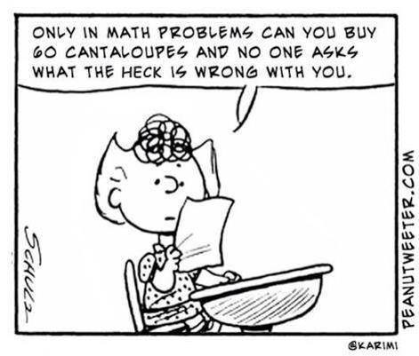
Tests/Quizzes 75%

**Your final mark will be made up of both terms cumulatively worth 75% and a final exam worth 20%.

As this course covers a great deal of content, we will be moving very quickly. It is important to do all the work promptly because there will be no time to catch up. Again, attendance is critical for success.

Classroom Policies:

1. Students are expected to be in class prior to the bell. Being late disrupts both the teacher and the rest of the class. When late, please acquire a late slip from the office, hand it in, then take your seat quietly.
2. Attendance is a key component of student success. Remember, if you miss a class, you miss 80 min. of class time!
3. Perfect attendance is expected on test days. If you are very ill on one of these days, a note/e-mail/call from a parent or guardian to excuse your absence is required and the test will be made up at the earliest possible time.
4. Do NOT bring a cell phone to class. 1st offence will be a polite warning. Second offence, you will be asked to bring your phone to the office. If it is a continual issue, a parent/guardian will be notified.
5. Please do not ask to go to the washroom every period. One student is allowed out at a time.
6. Eating is not allowed in class, as it is a science lab as well as a math classroom.
7. Come to class ready to learn, participate, and have fun.

Notes on Plagiarism and Cheating:

- Honesty is very important to me.
- If you cheat, parent/guardian and administration will be notified.
- Repercussions will follow school policy.

Communication with Mrs. Sharp:

- There is lunch time and after school support. Times to be discussed in class.
- Website: mrsjsharp.weebly.com E-mail: jsharp@sd67.bc.ca
- My phone number at school is 770-7650 ext. 6134

PLEASE RETURN WITH THE SIGNATURES OF BOTH YOU AND YOUR PARENT/GUARDIAN

I have read and understand all of the above and accept it in full:

________________________________ __________________________________
Student’s Name Student’s Signature

________________________________ _______________________________________
Parent/Guardian’s Name Parent/Guardian’s Signature

Optional: I would like to be informed of my child’s marks by e-mail.

My e-mail address is: ___________________________________________________
(Please write clearly)

Comments/questions/concerns for Mrs. Sharp:

____________________________________________________________________________________________________________________________________________________________________________________________
____________________________________________________________________________________________________________________________________________________________________________________________

