**Financial Literacy**



**Budget:** A financial _________ that balances your ________________ and ______________________.



**Expenses:** an ______________ or _____________________ you pay for



* For ex) rent/mortgage, food, clothing, electricity, car, phone, etc.

**Variable expenses**: Items for which the _______________ you pay each month ________ change (ex. Food).



**Fixed expenses**: Items for which you pay the _____________amount for each month (ex. ______________).



Guidelines for making a budget:

1. Record all your ________________________ for a period of time.



* + Note where you can adjust your __________________________.



1. Identify _______________ & ____________________ term goals.



* + Build a _____________________ plan to meet these goals.



* + Make ______________________ be one of your goals.



1. Organize your budget into _______________________________.



* + _______________ vs. ___________________



1. Note your progress in paying off _________________.



* + Ex) mortgage, car loans, student debt

1. Pay more than the ___________________ on debts.



1. [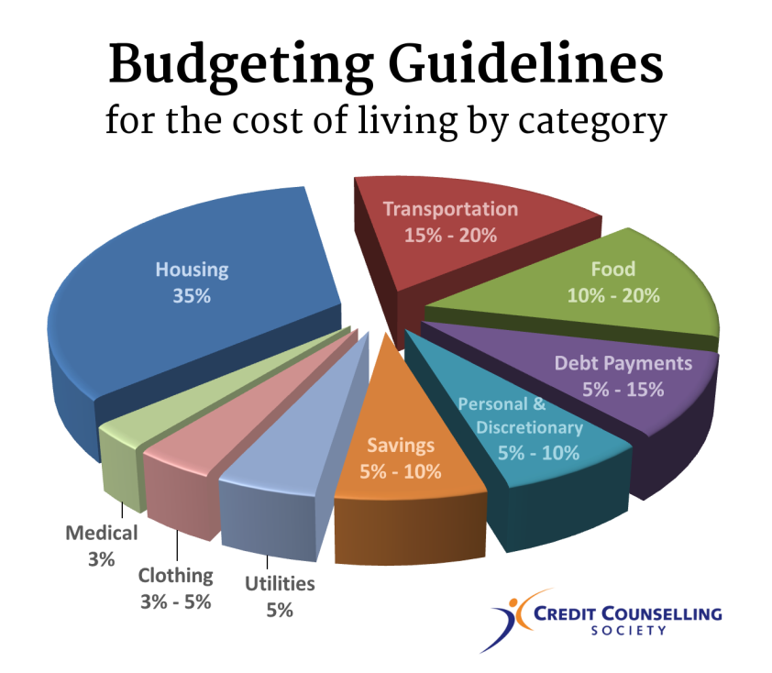](http://www.google.ca/url?sa=i&rct=j&q=&esrc=s&source=images&cd=&cad=rja&uact=8&ved=0ahUKEwiDt4eoiZPRAhUBVWMKHQuuAi4QjRwIBw&url=http://www.nomoredebts.org/budgeting-guidelines&psig=AFQjCNG_UiRESjHmuHnWi2eHkz9FYRYDnA&ust=1482883377411312)Stick to your ___________________.



Example 1: The following represent the monthly budget for two people sharing a small home driving two vehicles. Calculate the percentage for each budgeted item.



|  |  |  |  |
| --- | --- | --- | --- |
| **Expense** | **Amount** | **Calculations** | **Percentage** |
| Housing | 1000 |  |  |
| Utilities | 520 |  |  |
| Food | 500 |  |  |
| Transportation | 700 |  |  |
| Clothing | 50 |  |  |
| Health Care | 50 |  |  |
| Entertainment | 250 |  |  |
| Personal Care | 125 |  |  |
| Student Loans | 350 |  |  |
| TOTAL: |  |  |  |



Example 2: The monthly income of the couple in Ex. 1 has increased by 15%, but their expenses have also changed as follows:



Utilities – Up $50 (due to increased cost of living)



Food – Up $60 (due to increased cost of living)



Transportation – Down $100 (due to new job closer to home)



Personal care – Up $25 (due to increased cost of living)



Do their overall savings increase of decrease?



**Transactions:** Methods for __________________________ for things.



* For ex) cash, cheque, credit card, buy on terms

|  |  |  |  |
| --- | --- | --- | --- |
| **Method** | **Description** | **Advantage** | **Disadvantage** |
|  | A deduction from the usual cost. |  | _________& ___________ to find discount. |
|  | Buy now & pay later. | _________________ & ______________  Don’t miss out on item. | Impulse buying  ______________________  Interest if not fully paid on time. |
|  | Buy now & make payments over time. | Can ________ item while making payments. | Need a __________income.  Can be repossessed.  May be _______interest. |
|  | Payment with debit card, cheque, or actual cash. | Accepted everywhere.  Can mean a ____________.  Reduces impulse buying. | Carrying ________amounts of money is unsafe.  Miss out on an item if you don’t have the __________. |

**Credit:** The ________________ which allows one party to provide _________________________________ to another party where that second party does not reimburse the first party immediately.



* Helps purchase “_____________________________________” items



* Costs money to borrow



* Longer it takes to pay off, the _________________ credit you pay



* May require a _______________________________________



Example 3: John buys a new X-box One for $329.00 with an additional controller for $50 with 7% PST and 5% GST. If he agrees to monthly payments of $40 for 12 months, how much was the cost of this credit?



**Annual percentage rate**: The _____________________of yearly interest you must pay for the credit.



$$R=\frac{24C}{B\left(n+1\right)}x100$$

R = annual percentage rate

C = credit cost

B = amount borrowed

n = number of payments

Example 4: Calculate the annual percentage rate in Example 3.



Example 5: What is the annual percentage rate when $7000 is borrowed for 60 payments of $150?



**Interest:** Money that is paid for the __________________of your _________________________.



* If money is borrowed, interest if paid to the ________________________.



* If money is saved, interest is paid to the _______________________________________________.

1. **Simple interest:** 
   * calculated only on the principal amount of a loan

I =



I = amount of interest

P = principal (amount borrowed/lent)

R = annual interest rate



T = time in years



Example 6: Calculate the simple interest on $5000 invested at 3.5% for 10 years.



1. **Compound Interest:**



* + is calculated on the _____________________ amount & on the accumulated **_______________** of previous periods



* + “Interest on your interest”
  + Can be compounded annually, semi-annually, quarterly, or daily



[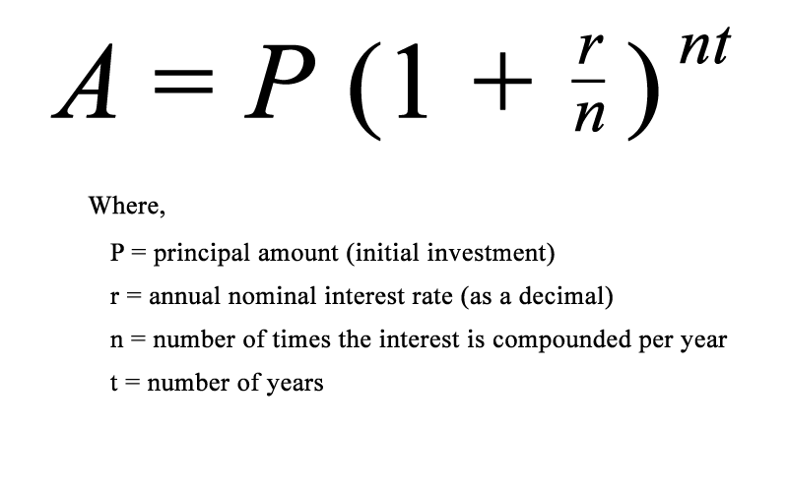](http://www.google.ca/url?sa=i&rct=j&q=&esrc=s&source=images&cd=&cad=rja&uact=8&ved=0ahUKEwi2u4Tvm5PRAhUG72MKHeQsASYQjRwIBw&url=http://www.investmentzen.com/blog/why-compound-interest-isnt-as-powerful-as-you-think/&psig=AFQjCNEBOQcGyeSMkxcL8JabNSKlzUVw7A&ust=1482888333738937)



Example 7: Calculate the amount in an account if $5000 is invested at 3.5% compounded annually for 10 years.



Example 8: Calculate the total amount paid after a $8000 car loan is paid off after 5 years at 6% compounded semi-annually.

