GMO Research Project

Background:
The purpose of this research assignment is for you to apply your knowledge and understanding of genetics within the context of real-world applications. More specifically, as scientific progress and technological innovation within the field of genetic engineering become more established, the ability to genetically modify living organisms will become increasingly simplified. Your task will be to assess the genetically modified food industry in order to determine the benefits, potential risks, and controversies associated with commonly consumed GMO foods.

Task: Please answer each of the following questions:
- What is a genetically modified organism/food? Give examples.
- What was the first GM food commercially available? When did this food become available?
- What benefits do GM foods offer? (Ex: consumer, economic, global, etc.)
- What risks do GM foods present? (Ex: consumer, economic, global, etc.)
- What are the laws/regulations affecting GM foods in Canada?
- In your opinion, do consumers have a right to know if the foods they are buying contain GMOS?
- How do you personally feel about GM foods? If the foods you enjoy eating were genetically modified, would you consider changing your diet?

You may present your research in the form of a research paper, poster, Prezi or PowerPoint presentation. While you may include any information that you find relevant, you MUST include at minimum answers the each of the questions listed above. If presenting on a poster or in a paper, it MUST be typed, 12 points, and double-spaced. While there is no specific page length, your responses will be graded based upon quality and thoroughness of response.

Remember that you must communicate your own ideas. Plagiarism will result in your project being returned to you unmarked. Once rewritten in your authentic voice, you may resubmit the work.

References:
As with any research assignment, the quality of sources referenced is paramount. Therefore, you must include a minimum of three references in your research. You may use information from websites, books, or periodicals; however, opinion-based sources such as Wikipedia are NOT allowed.
You should use APA formatting for your bibliography (mybib.com may help), your references should be in alphabetical order and listed on a separate page at the end of your paper/presentation.

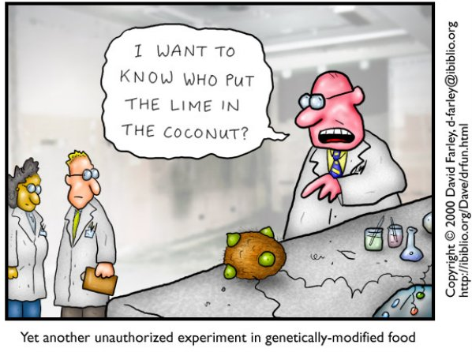

 | 1 | 2 | 3 | 4 | 5
Research (x2) | More than 6 research questions have been missed or answered incorrectly. | 5-6 research questions have been missed or answered incorrectly. | 3-4 research questions have been missed or answered incorrectly. | Only 1-2 research questions have been missed or answered incorrectly. | All research questions have been answered and are correct.
Research (x2) | Questions lack thought and are poorly communicated. | Many questions are lacking thought and/or are not well communicated. | Some questions are fully and thoughtfully answered. Answers are communicated clearly. | Most questions are fully and thoughtfully answered. Answers are communicated clearly. | All research questions have been fully & thoughtfully answered. Answers are communicated clearly.
Communication:  - Organization  - Appearance  - Spelling/Grammar | The presentation is poorly organized, difficult to follow, and appears to have little/no effort towards a professional appearance. Significant grammatical or spelling errors. | The presentation is well organized, easy to follow, and neatly presented. There are a few grammatical or spelling errors | The presentation is exceptionally well organized, easy to follow, and very professionally presented. There are minimal grammatical or spelling errors.
Sources | 3 or more sources are listed but not correctly cited. Or only 2 properly cited sources. | 3 or more sources are listed and correctly cited.

