Rates of evolution activity Name:__________________________
(Gradualism vs Punctuated equilibrium)

Determine whether the examples below support Punctuated equilibrium or Gradualism.

This graph shows ____________________ This graph shows ____________________

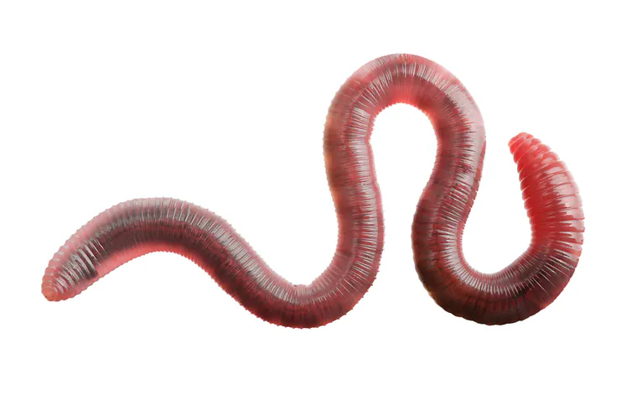
Ex 1: A species of worms lives in the soil in a particular climate and is in a state of stasis. Climate changes cause the pH of the soil to change. The change in pH causes some worms to die, but those that survive adapt and reproduce with a new ability to withstand the pH change in the soil. The species returns to stasis. ____________________________

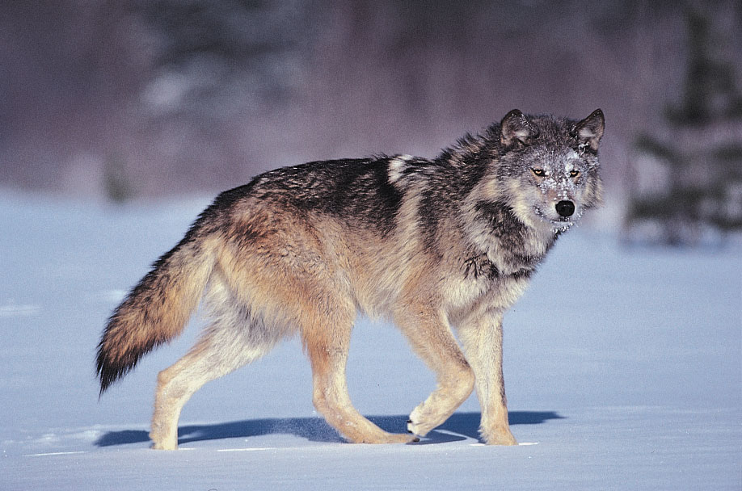
Ex 2: Small variations occur over time in a population of wolves — larger ears, longer teeth and a heightened sense of smell. Wolves with these helpful traits tend to survive better than those without; as time progresses slowly, the traits gradually become the norm among the population. _____________________
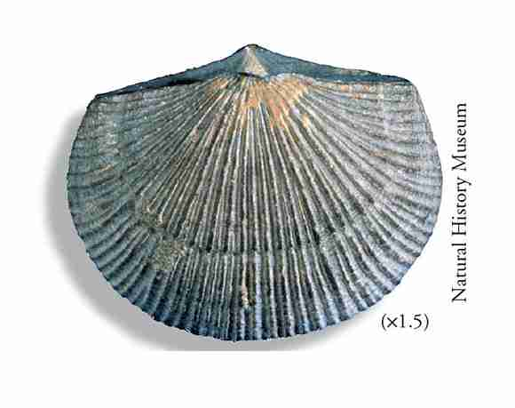

Ex 3: Fossils of Brachiopods show a "sudden transition" between the species Kutchithyris acutiplicata and K. euryptcha. The rapid transition can only be explained by a sudden need for evolutionary change. _____________________

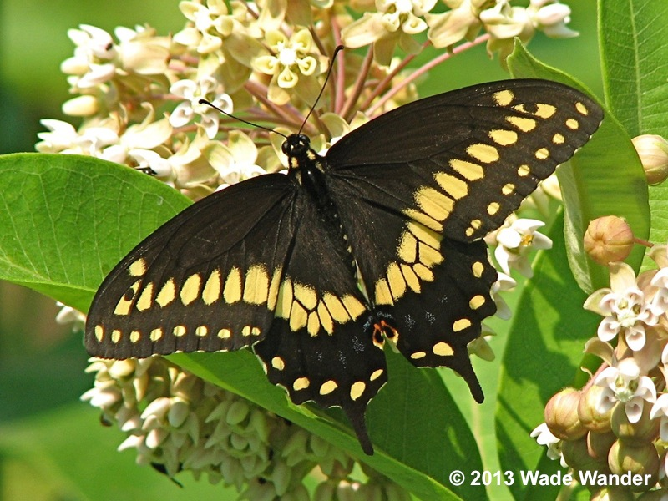
Ex 4: A species of butterfly is yellow and black in color. However, a butterfly is born that happens to be orange and yellow in color making it difficult to see. Over a long period of time, the yellow and black butterflies die out, because the orange and yellow color combination makes the butterflies less visible to predators. _____________________

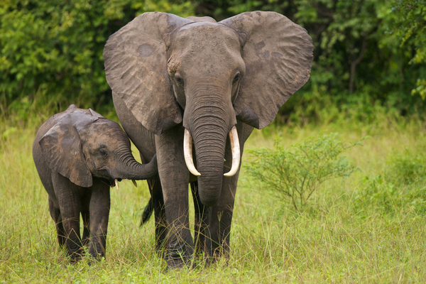
Ex 5: Over a period of many, many years, a population of elephants develops larger ears to help protect the elephants from the sun and keep them cool. This larger ear eventually becomes a physical feature of the entire population of elephants. ______________________

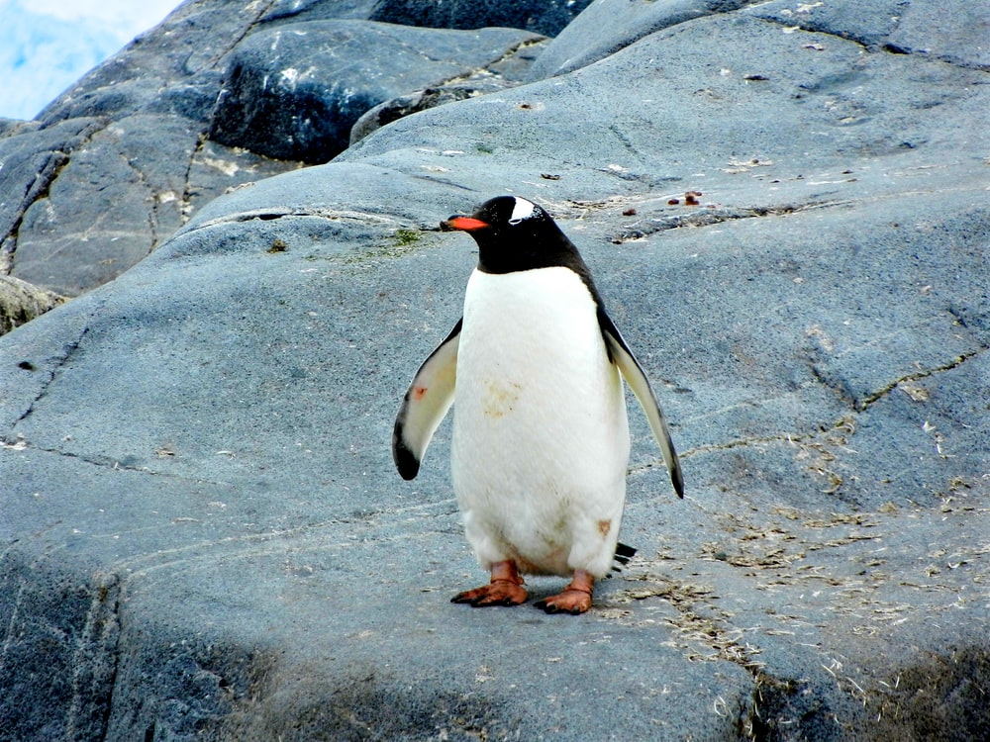
Ex 6: Small variations appear over a long period of time among a population of penguins, including thicker coats of down that allow them to survive in very cold climates. Penguins with these traits survive much better than those with thinner down coats, leading to the changes becoming standard among all penguins. _____________________

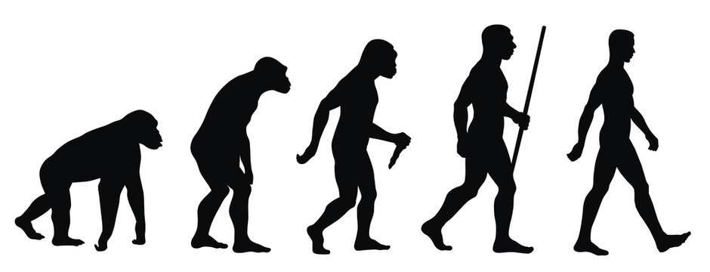
Ex 7: In the evolution of ape to man there are periods of rapid and pronounced change surrounded by large periods of no change at all. ________________________

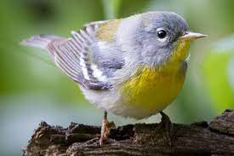
Ex 8: A species of birds exist in stasis for many thousands of years. Suddenly, bacteria cause their primary tree of sheltering choice to die. The population of birds sees a quick change in wing strength in the next couple generations, as the new trees that the species starts to shelter in have much higher branches for them to fly up to. ________________________

