Homologous, Analogous & Vestigial Structures
Life Sciences 11
Name: ______________________
Date: _________________

Background:
In studying evolutionary history, there are often patterns found in evolution. Over time, species with the best adaptations survive and reproduce to pass on those beneficial genes. In studying
phylogenies and building cladograms it is important to consider the importance of homologous and analogous, and vestigial structures. Each of these structures will help you understand whether species have shared ancestry or if similar traits evolved separately.
There are three patterns that occur during evolution that are often related to the adaptation and
evolution of these structures.
1. Convergent evolution: Process in which two different lineages evolve a similar characteristic independently of one another. This often occurs because both lineages face similar environmental challenges and selective pressures.

2. Divergent evolution: Process in which one common lineage evolves due to differences between species. This can lead to the formation of new species (speciation). This is typically a result of genetic drift and natural selection.

3. Co-evolution: Process where two (or more) species reciprocally affect each other's evolution.
Coevolution is likely to happen when different species have close ecological interactions with one another.

Using your lecture notes and/or the textbook, define the following terms.

I) Analogous Structures:

a) What type of evolution do you think typically illustrates analogous structures? Explain.
Convergent? Divergent? Co-evolution?

II) Homologous Structures:

a) What type of evolution do you think typically illustrates homologous structures?
Convergent? Divergent? Co-evolution?

III) Vestigial Structures:

a) What type of evolution do you think typically illustrates vestigial structures?
Convergent? Divergent? Co-evolution?

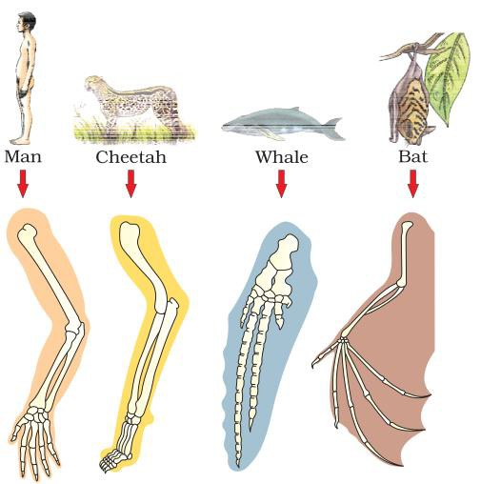

1. Identify the above forelimb structures as to whether they are homologous, analogous or vestigial structures. Why?

2. What evolutionary pattern is most likely to have caused these limbs to evolve in this way? Why?

3. Using colored pencils, color code the bones that are similar in each animal.

4. Number the fingers and/or toes of each of the animals above.

5. What are the similarities and differences in each part of the forelimb? (Upper arm, lower arm, wrist, hands & toes/fingers)
Ex. All four animals have only 1 bone in the upper arm (humerus)

6. Why would these have evolved differently?

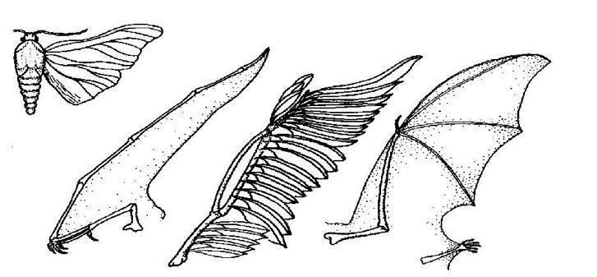The following wings belong to the moth, Pterodactyl, bird and bat

1. Identify the above forelimb structures as to whether they are homologous, analogous or vestigial structures. Why?

2. What evolutionary pattern is most likely to have caused these limbs to evolve in this way? Why?

3. What are the similarities and differences in each part of the forelimb? (Upper arm, lower arm, wrist, hands & toes/fingers)
Ex. All four animals have only 1 bone in the upper arm (humerus)

4. Why would these have evolved differently?

The following traits are no longer essential for humans.

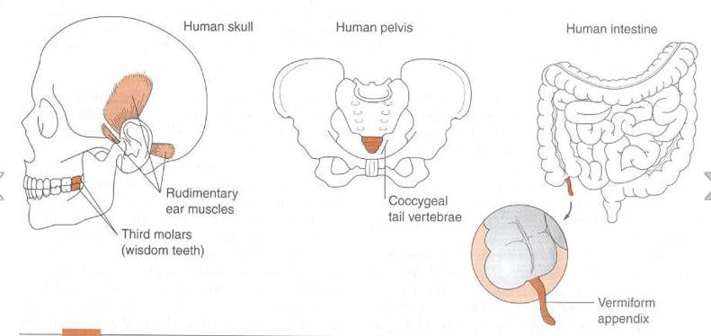

1) Identify the above human structures as to whether they are homologous, analogous or vestigial structures. Why?

2) Discuss in your group and predict why these structures are not essential to humans?

Extension: Follow-up by researching what these four structures were used for and why we can live without them. “See if your predictions were correct”.

