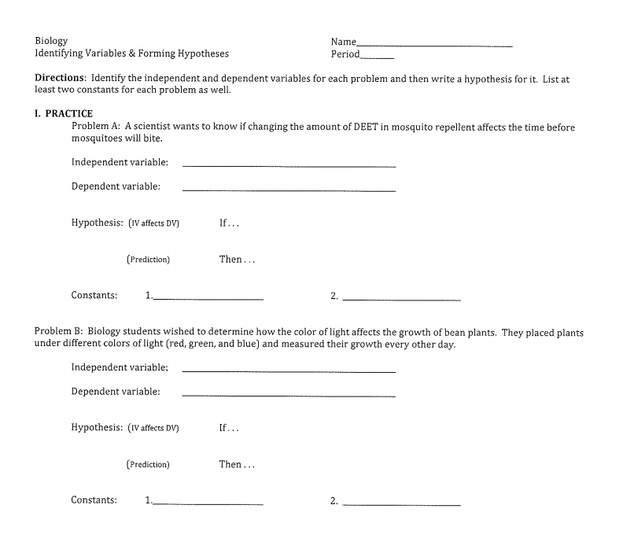

**Homework:**

**Experiment** **1** Smithers thinks that a special juice will increase the productivity of workers. He creates two groups of 50 workers each and assigns each group the same task (inthis case, they're supposed to staple a set of papers). Group A is given the special juice to drink while they work. Group B is not given the special juice. After an hour, Smithers counts how many stacks of papers each group has made. Group A made 1,587 stacks, Group B made 2,113 stacks.

**Answer**:

1. Which is the control group? _________________________________________________

2. Which is the experimental group? ____________________________________________

3. Identify the independent variable. ___________________________________________

4. Identify the dependent variable. ____________________________________________

5. Given the experimental design, what should Smithers' conclusion be? __________________

_______________________________________________________________________

6. How do you think the experiment could be improved? ______________________________

_______________________________________________________________________

**Experiment 2**  Homer notices that his shower is covered in a strange green slime. His friend Barney tells him that coconut juice will get rid of the green slime. Homer decides to check this out by spraying half of the shower with coconut juice. He sprays the other half of the shower with water. After 3 days of "treatment" there is no change in the appearance of the green slime on either side of the shower.

**Answer:**

1. What hypothesis is Homer trying to test? ______________________________________

2. What is Homer's conclusion? ________________________________________________

3. What is the control group? _________________________________________________

4. What is the experimental group? ____________________________________________

5. What is the independent variable? ___________________________________________

6. What is the dependent variable? _____________________________________________

**Experiment 4** Krusty was told that a certain itching powder was the newest best thing on the market. It even claims to cause 50% longer lasting itches. Interested in this product, he buys the itching powder and compares it to his usual product. One test subject (A) is sprinkled with the original itching powder, and another test subject (B) was sprinkled with the Experimental itching powder. Subject A reported having itches for 30 minutes. Subject B reported to have itches for 45 minutes.

**Answer:**

1. What is the control group? _________________________________________________

2. What is the experimental group? ____________________________________________

3. What is the independent variable? ___________________________________________

4. What is the dependent variable? _____________________________________________

5. Does the data support the advertisements claims about its product? Why or why not?

_________________________________________________________________________

_________________________________________________________________________