[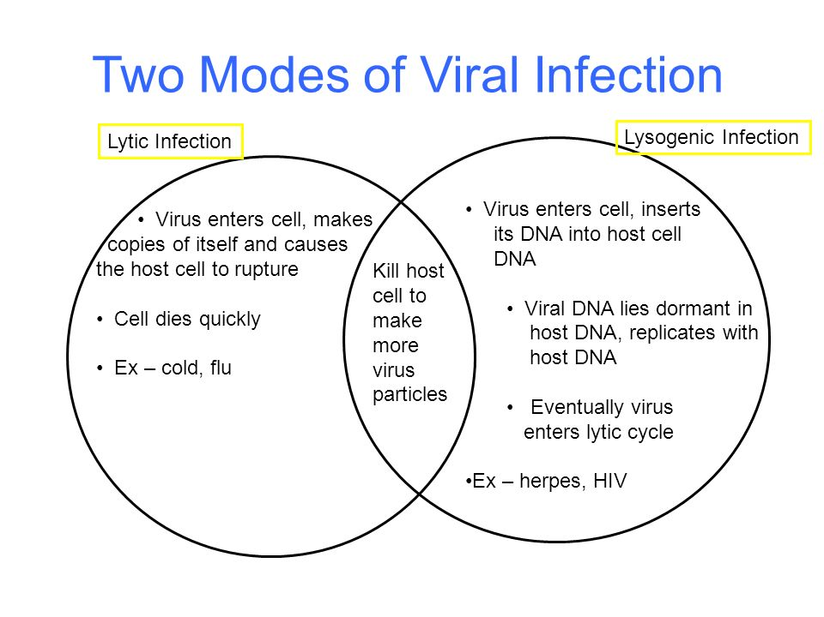](http://www.google.ca/url?sa=i&rct=j&q=&esrc=s&source=images&cd=&cad=rja&uact=8&ved=2ahUKEwivpNCBqrjaAhUpqlQKHWqdCjsQjRx6BAgAEAU&url=http://slideplayer.com/slide/6401276/&psig=AOvVaw26DuorRGH7nB3LvGnZ6h10&ust=1523745595687901)

[](http://www.google.ca/url?sa=i&rct=j&q=&esrc=s&source=images&cd=&cad=rja&uact=8&ved=2ahUKEwivpNCBqrjaAhUpqlQKHWqdCjsQjRx6BAgAEAU&url=http%3A%2F%2Fslideplayer.com%2Fslide%2F6401276%2F&psig=AOvVaw26DuorRGH7nB3LvGnZ6h10&ust=1523745595687901)

[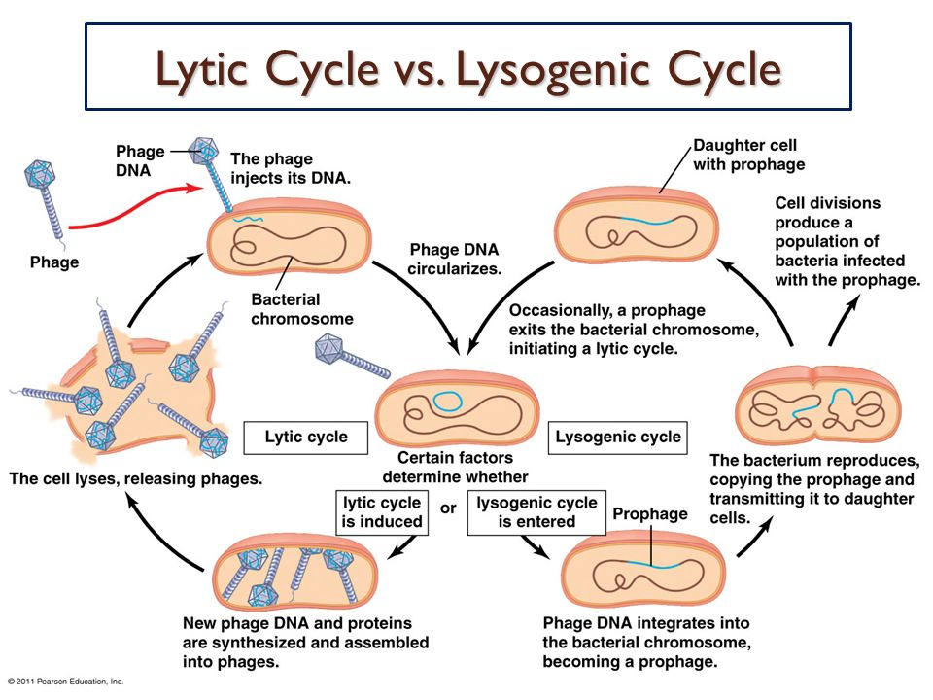](http://www.google.ca/url?sa=i&rct=j&q=&esrc=s&source=images&cd=&cad=rja&uact=8&ved=2ahUKEwjpppvQqbjaAhXohlQKHVPLDGAQjRx6BAgAEAU&url=http://vit.tpkit.ru/starviba/picture-of-lysogenic-infection7824.php&psig=AOvVaw26DuorRGH7nB3LvGnZ6h10&ust=1523745595687901)