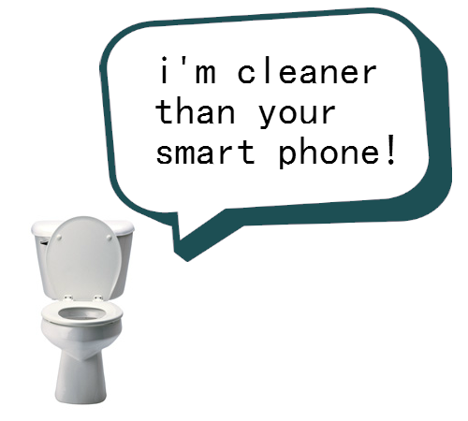
Microbiology Test Outline
Reading: Viruses - Ch.17 pp.355-360, Ch. 45-2 pp. 972-976
Microscopes – Appendix C
Bacteria – Sections 17.2 & 17.3

Concepts to study:
Viruses:
_____ 1. Describe and be able to label the parts of a virus (bacteriophage).
_____ 2. Know the function of the parts of a virus.
_____ 3. Recognize diagrams & describe the sequence of events for the lytic cycle.
_____ 4. Recognize diagrams & describe the sequence of events for the lysogenic cycle.
_____ 5. Explain how a retrovirus different from an average viral particle.
_____ 6. Know the three theories of viral origin.
_____ 7. Give arguments for viruses being living beings versus non-living particles.
_____ 8. Give ways to prevent viral infection.

Microscopes:
_____ 1. Be able to label a diagram of a microscope & explain the functions of its parts.
_____ 2. Explain the difference between a simple, compound, & electron microscope.
_____ 3. Be able to calculate magnification.

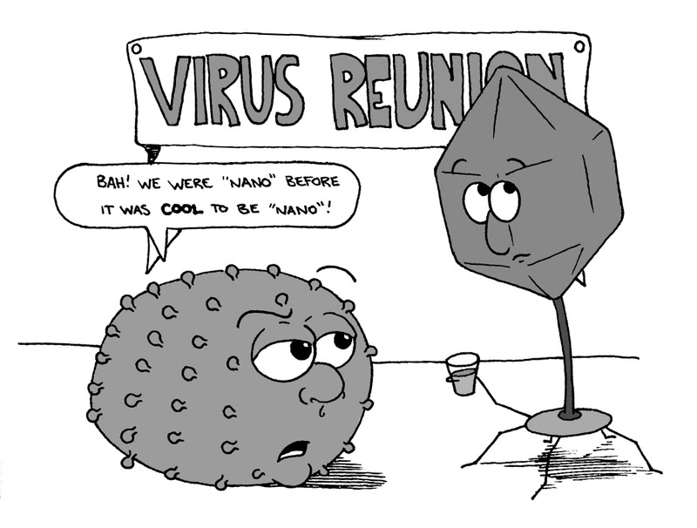

Bacteria:
_____ 1. Describe similarities & differences between Eubacteria & Archaebacteria
_____ 2. Be able to label a diagram of a basic bacterium.
_____ 3. Know how to classify bacteria by shape (cocci, bacilli, spirilli) & arrangement (solitary, diplo, strepto, staphlo).
_____ 4. Describe the difference between Gram + & – bacteria based on cell wall structure & staining
_____ 5. Be able to explain binary fission and conjugation.
_____ 7. Know positive uses/roles of bacteria.
_____ 8. Describe how you can prevent bacterial infection.

You should also:
- read the assigned reading
- go through your notes
- know your vocabulary (on the course outline & new
words in your notes)
- review your labs & worksheets
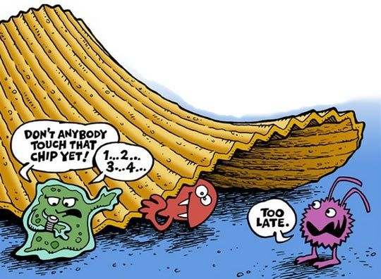
- ask questions

