Chapter 6 – Photosynthesis and Cellular Respiration Project

Task:

- Read Ch.6 & pay particular attention to the words listed below.
- Using these 25 words plus your notes, draw a plant cell & an animal cell on the sheet of paper provided. Note: Ch. 5 has a picture of plant & animal cell.
- Draw and label the organelles involved in photosynthesis & cellular respiration (only one cell will have all of them!)
- Include the chemical equations for photosynthesis and cellular respiration.
- In a creative manner, show all the links connecting words below in a diagram
- Take a few minutes to read through the rubric on the back to understand how the assignment will be assessed.
- Ask questions!
Vocabulary:

- Photosynthesis
- Sun
- Sunlight
- Plant
- Animal
- Mitochondria
- Cytoplasm
- Chloroplast
- Chlorophyll
- Autotrophic
- Heterotrophic
- Cellular respiration
- Glycolysis
- Respiration
- Fermentation
- Anaerobic
- Aerobic
- Glucose
- Oxygen
- Carbon dioxide
- Water
- ATP (Energy)
- Lactic acid
- Alcohol
- Diffusion

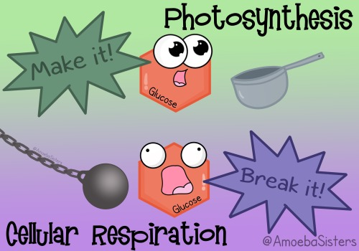
 | 1 | 2 | 3 | 4 | 5
Cell Diagrams | There are more than 3 errors to labelling the cell diagrams and/or processes. | There are 1-2 errors in labelling the cell diagrams. | Cell diagrams are completely & correctly labelled.
Chemical Equations | The chemical equations for photosynthesis & cellular respiration are included but have many errors. | The chemical equations for photosynthesis & cellular respiration are included but have an error or two. | The chemical equations for photosynthesis & cellular respiration are included and correct.
Connecting Ideas | All words used are linked correctly however more than 12 links have been missed or are difficult to understand. | All words used are linked correctly however 9-12 links have been missed or are difficult to understand. | All words used are linked correctly however 6-8 links have been missed or are difficult to understand. | All words used are linked correctly however 3-5 links have been missed or are difficult to understand. | All words used are linked correctly, and only 1-2 links have been missed or are difficult to understand.
Vocabulary | Less than 10 words have been included and used/defined correctly. | 10-14 words have been included and used/defined correctly. | 15-18 words have been included and used/defined correctly. | 19-23 words have been included and used/defined correctly. | 23-25 words have been included and used/defined correctly.
Communication:  - Organization  - Appearance  - Spelling/Grammar | The presentation is poorly organized, difficult to follow, and unattractive and/or there are many grammatical or spelling mistakes. | The presentation is fairly well organized and appears to have some effort put towards a neat presentation. There are many grammatical or spelling mistakes. | The presentation is well organized, easy to follow, and neatly presented. There are few grammatical or spelling mistakes | The presentation is exceptionally well organized, easy to follow, and very professionally presented. There are minor grammatical or spelling mistakes

