Recognizing Relationships using Taxa
You can tell how closely related species are by analyzing their taxa. Look at the following table. Using deduction, fill in the missing information. Once complete, answer the analysis questions.

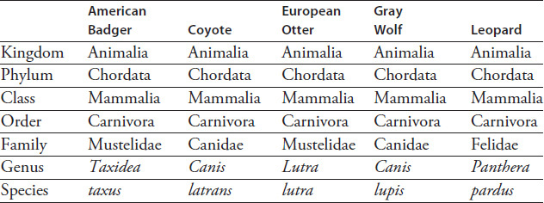

Analysis:
- a). Which animal is most closely related to the American Badger? _________________________
b). How can you tell by looking at the taxa? __________________________________________

- a). Which two animals are most closely related? _________________________
b). How can you tell by looking at the taxa? __________________________________________

- Which animals can you be certain are carnivores?
______________________________________________________________________________

