BIOLOGY 11 UNIT OUTLINE

UNIT 4: TAXONOMY

A. Chapter 15: Classification Systems pp. 318-333

Learning Outcomes:

It is expected that students will:

- apply the Kingdom system of classification to study the diversity of organisms

Knowledge:

- principles of taxonomy
  - taxa
  - phylogenetic tree and cladogram
  - dichotomous key
- taxonomy principles for classifying organisms:
  - binomial nomenclature
- unifying characteristics of the evolutionary continuum across the kingdoms
  - characteristics of the three domains Archaea, Bacteria, Eukarya
  - characteristics of the kingdoms Archaebacteria, Eubacteria, Protista, Fungi, Plantae, and Animalia
Vocabulary:

Animalia, Archaebacteria, binomial nomenclature, biochemical relationship, cladogram, class, dichotomous key, embryological relationship, Eubacteria, eukaryotic cell, family, Fungi, genus, homologous structure, Monera, kingdom, order, phylogenetic tree, phylum, Plantae, prokaryotic cell, Protista, species, taxonomy, taxon
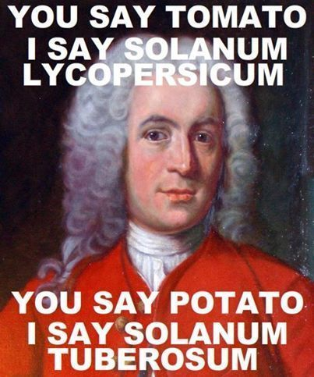
Taxonomy (Classification) Test Outline
Reading: Ch.15 pp.318-333

Concepts to study:
_____ 1. Explain why we classify organisms.
_____ 2. What language is used in classification?
_____ 3. Explain what is used to help classify organisms.
_____ 4. Who developed binomial nomenclature?
_____ 5. Describe how you properly use binomial nomenclature.
_____ 6. Recognize proper binomial nomenclature
_____ 7. Name the 8 taxa in order from smallest to largest or most general to most specific.
_____ 8. Know a human being’s complete taxonomic classification.
_____ 9. Be able to distinguish which organisms are more closely related by their classification.
_____ 10. Distinguish between prokaryotic & eukaryotic cells.
_____ 11. Distinguish between the 3 domains of life & give examples in each.
_____ 12. Distinguish between the 6 kingdoms of life & give examples within each.
_____ 13. Give similarities & differences between the 6 kingdoms.
_____ 14. Given descriptors, be able to distinguish which kingdom the unknown organism belongs.
_____ 15. Explain what a dichotomous key, a phylogenetic tree, and a cladogram is.
_____ 16. Be able to use a dichotomous key, a phylogenetic tree, and a cladogram.
_____ 17. Be able to design a small dichotomous key and a cladogram.

You should also:
- read the assigned reading
- go through your notes
- know your vocabulary (on the course outline & new words in your notes)
- review your textbook questions & worksheets
- ask questions

