BIOLOGY 11 UNIT OUTLINE

UNIT 5: MICROBIOLOGY

A. Chapter 17: Viruses & Bacteria pp. 354-379
B. Appendix C: Care & Use of the Microscope

Content:

It is expected that students will know the following:

Viruses
• definitions of living vs. non-living
• basic structure of viruses
• viral reproduction (lytic and lysogenic cycles)
• effects of viruses on organisms
Archaebacteria & Eubacteria (Monera)
• unifying characteristics
• structure and function of bacteria
• evolutionary trends

Vocabulary:

Viruses: antibody, antigen, bacteriophage, capsid, DNA, fibrils, host cell, lysogenic cycle, lytic cycle, pathogen/pathogenic, phagocytic white blood cell, prophage, retrovirus, RNA, tail sheath, vaccine, viral specificity

Microscopes: compound microscope, depth of field, diaphragm, electron microscope, field of view, gram positive, gram negative, light microscope, magnification, objective lenses, ocular lens, SEM, TEM

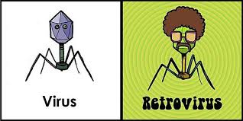
Archaebacteria & Eubacteria: aerobic, anaerobic, antibiotic, autotrophic, bacilli, bacteria, binary fission, capsule, cocci, conjugation, diplo, endospore, facultative aerobe, fermentation, flagella, gram +/-, methanogens, motility, mutate/mutation, nitrogen fixation, obligate aerobe, obligate anaerobe, pili, prokaryote, resistant/resistance, saprophytes, spirilla, stapho, strepto, thermophiles

